Internal Quarterly Report

Date of Report: 2nd Quarterly Report – April 7, 2025
Contract Number: 693JK32410014POTA
Prepared for: DOT / PHMSA
Project Title: Use of Gamification and Generative AI to provide more effective training for hazardous condition and emergency response.
Prepared by: EnerSys Corporation
Contact Information: Russel W. Treat
E: rtreat@enersyscorp.com
O: 281-598-7110
M: 281-804-6171
For quarterly period ending: March 31, 2025

1: Items Completed During this Quarterly Period:

Item # | Task # | Activity/Deliverable | Title | Federal Cost | Cost Share
2 | 2 | Conduct Kick Off Meeting, Revise Project Plan and Research Program. | Project Plan and Research Scope | 2,664.00 | 4,000.00
10 | 7 | Define multi-player game prototype | Develop Generative AI Model and Multi-Player training scenarios | 8,056.00 | 34,120.00
11 | 13 | 2nd Quarterly Status Report | Submit 2nd Quarterly Report | 5,952.00 | 1,140.00

2: Items Not-Completed During this Quarterly Period:

Item # | Task # | Activity/Deliverable | Title | Federal Cost | Cost Share
3 | 3 | Research, summarize and document current practice for performing Team Training. | Summary of current industry practice for conducting Emergency Response, Team Training, and Exercises. | 5,360.00 | 20,000.00
5 | 3 | Research, summarize and document current practice for performing emergency and hazardous condition response. | Define generative AI training criteria for Team Training scenario for Liqiud Pipeline Hazardous Condition Response. | 5,360.00 | 20,000.00
6 | 3 | Research, summarize and document current practice for performing Emergency Response Exercises. | Summary of current industry practice for conducting Emergency Response, Team Training, and Exercises. | 5,360.00 | 20,000.00
7 | 4 | Define generative AI training criteria for Team Training and Exercise scenarios. | Specification of Training Scenarios, AI training materials, Training Outcomes and Multi-Player. | 3,776.00 | 6,840.00
8 | 5 | Define materials for use in training generative AI model | Specification of Training Scenarios, AI training materials, Training Outcomes and Multi-Player. | 11,256.00 | 9,120.00

3: Project Financial Tracking During this Quarterly Period:

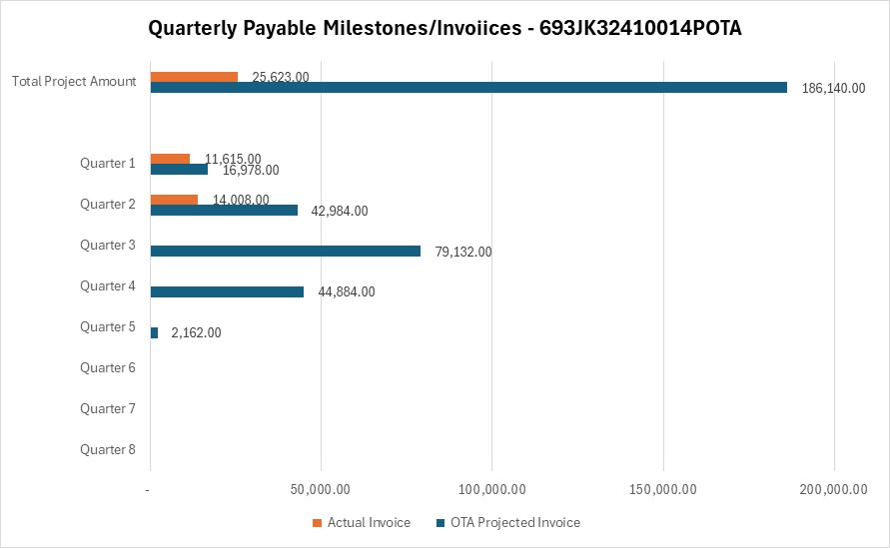

4: Project Technical Status

Item # | Task # | Activity/Deliverable | Title
2 | 2 | Conduct Kick Off Meeting, Revise Project Plan and Research Program. | Project Plan and Research Scope
The Project Kick Off was held on January 15, 2025 via MS Teams screen share.
10 | 7 | Define multi-player game prototype | Develop Generative AI Model and Multi-Player training scenarios
The multi- player prototype design was completed during the quarter, and the design document has been loaded to the PHMSA project page.
11 | 13 | 2nd Quarterly Status Report | Submit 2nd Quarterly Report
Completed and submitted 2nd Quarterly Report.

5: Project Schedule

Item # | Task # | Activity/Deliverable | Title
3 | 3 | Research, summarize and document current practice for performing Team Training. | Summary of current industry practice for conducting Emergency Response, Team Training, and Exercises.
The initiation of the research tasks has been deferred until a relationship can be formalized with the Mary K O’Connor Process Safety Center. The center has expressed a commitment to participate, and contracts have been exchanged and negotiated. A final review of the agreement is required. Upon completion of the agreement, the research and data gathering tasks will be initiated.

A TAP meeting has been scheduled for May 21. At that time, the TAP members will be engaged in the research effort.
5 | 3 | Research, summarize and document current practice for performing emergency and hazardous condition response. | Define generative AI training criteria for Team Training scenario for Liquid Pipeline Hazardous Condition Response.
See answer to Item 3, Task 3 above.
6 | 3 | Research, summarize and document current practice for performing Emergency Response Exercises. | Summary of current industry practice for conducting Emergency Response, Team Training, and Exercises.
See answer to Item 3, Task 3 above.
7 | 4 | Define generative AI training criteria for Team Training and Exercise scenarios. | Specification of Training Scenarios, AI training materials, Training Outcomes and Multi-Player.
See answer to Item 3, Task 3 above.
8 | 5 | Define materials for use in training generative AI model | Specification of Training Scenarios, AI training materials, Training Outcomes and Multi-Player.
See answer to Item 3, Task 3 above.

